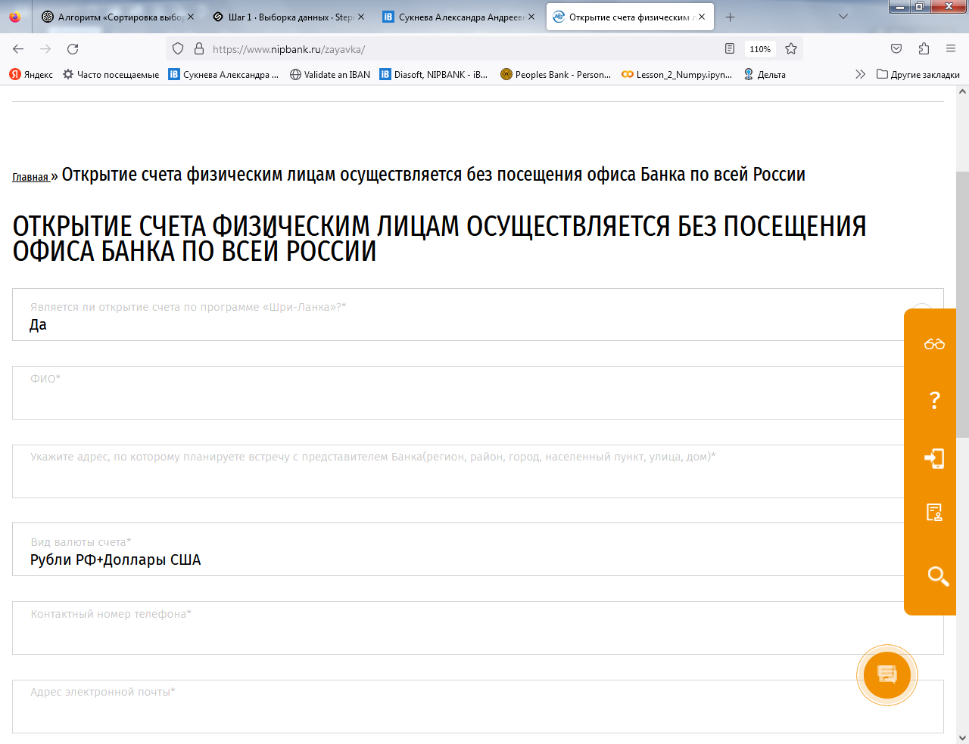

Email address

Contact phone number in Russia

Currency of the account

Specify the address at which you plan to meet with a representative of the Bank (region, city, street, house)\*

Family name, name

Do you wish to open an account under the program “Sri Lanka”?

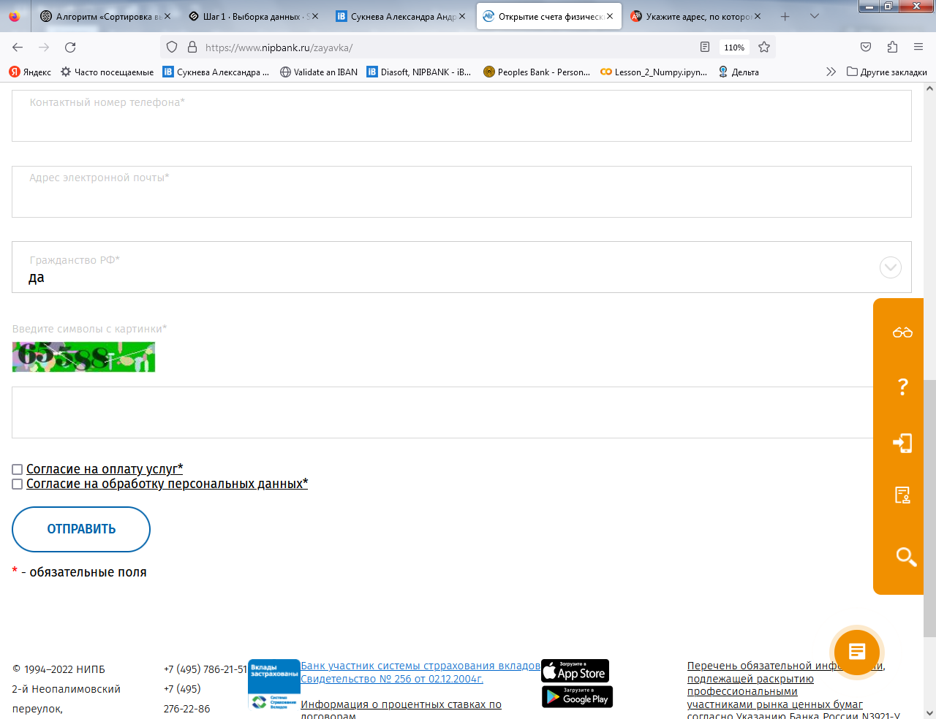

Press “Send”

* Agreement to pay commission for the services
* Agreement for personal data processing

Tick both

Enter the digits from the green field

нет

Citizenship of Russia